9 - SQL Homework - Steve Reiss

# —ERD CHART—

<https://app.quickdatabasediagrams.com/#/d/X9uBNG>

employees

emp_no INTEGER PK emp_title_id VARCHAR birth_date DATE first_name VARCHAR last_name VARCHAR sex VARCHAR hire_date DATE

departments dept_no PK VARCHAR dept_name VARCHAR

dept_emp -

emp_no INTEGER FK >- employees.emp_no dept_no VARCHAR FK >- departments.dept_no

dept_manager

-

dept_no VARCHAR

emp_no INTEGER FK >- employees.emp_no

salaries salary INTEGER

emp_no INTEGER FK >- employees.emp_no

titles

title_id VARCHAR title VARCHAR

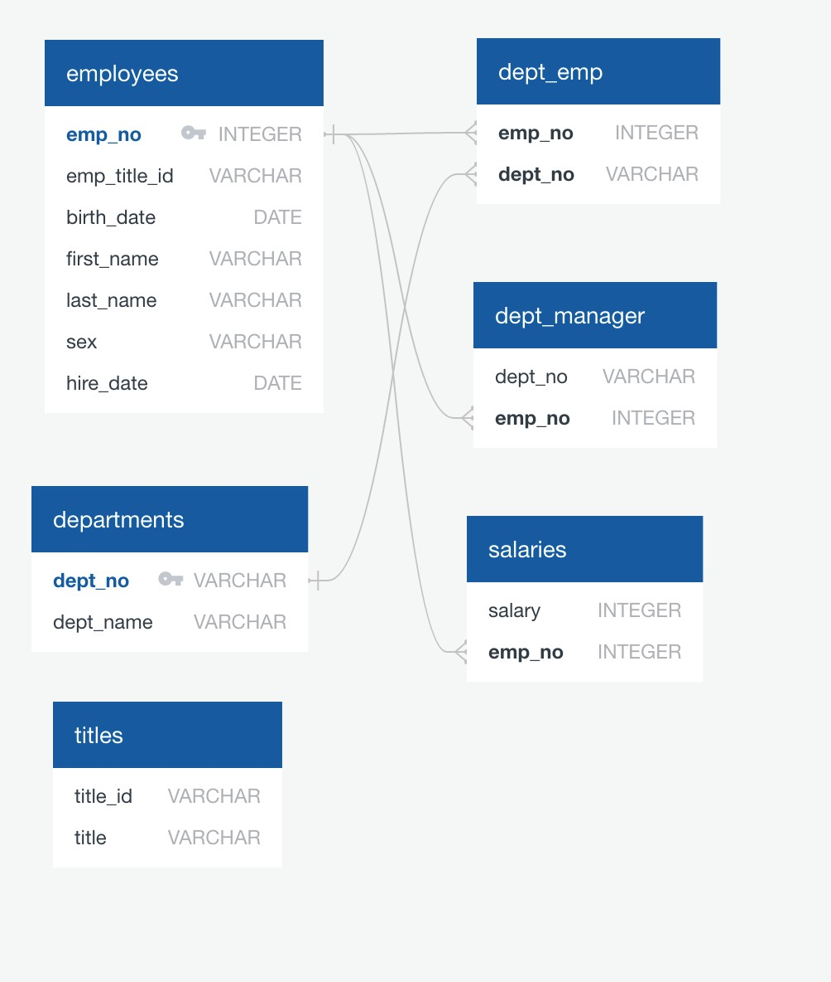

# —UPLOAD DATA FILES—

— employees.csv — DROP TABLE employees

CREATE TABLE employees ( emp_no INT NOT NULL, emp_title_id VARCHAR (10) NOT NULL, birth_date DATE, first_name VARCHAR (25) NOT NULL, last_name VARCHAR(25) NOT NULL, sex VARCHAR (2) NOT NULL , hire_date DATE,

PRIMARY KEY (emp_no)

);

—departments.csv— DROP TABLE departments

CREATE TABLE departments ( dept_no VARCHAR (10), dept_name VARCHAR(25),

PRIMARY KEY (dept_no)

);

—dept_emp.csv— DROP TABLE dept_emp

CREATE TABLE dept_emp ( emp_no INT *NOT NULL,* dept_no VARCHAR (10) NOT NULL,

FOREIGN KEY (emp_no) REFERENCES employees(emp_no),

FOREIGN KEY (dept_no) REFERENCES departments(dept_no)

);

—dept_manager.csv— DROP TABLE dept_manager CREATE TABLE dept_manager ( dept_no VARCHAR(10), emp_noINT,

FOREIGN KEY (emp_no) REFERENCES employees(emp_no)

);

—salaries.csv— DROP TABLE salaries

CREATE TABLE salaries ( emp_noINT, salary INT,

FOREIGN KEY (emp_no) REFERENCES employees (emp_no)

);

—titles.csv— DROP TABLE titles

CREATE TABLE titles ( title_id VARCHAR (10),

title VARCHAR (25)

);

# —UNIQUE TEST for primary key columns—

SELECT count(dept_no) FROM departments WHERE dept_no = Null;

SELECT count (emp_no) FROM employees

WHERE emp_no = Null;

—No Nulls for employees— (NOTE, primary keys cannot have nulls, just checking) —No Nulls for departments—

SELECT COUNT(emp_no)

FROM employees

GROUP BY emp_no

ORDER BY emp_no desc;

SELECT COUNT(dept_no)

FROM departments GROUP BY dept_no

ORDER BY dept_no desc;

—No dups for employees— (NOTE, primary keys cannot have dups, just checking) —No dups for departments—

# —DATA ANALYSIS—

—1—

SELECT employees.emp_no, employees.last_name, employees.first_name, employees.sex, salaries.salary

FROM employees

LEFT JOIN salaries

ON employees.emp_no = salaries.emp_no

;

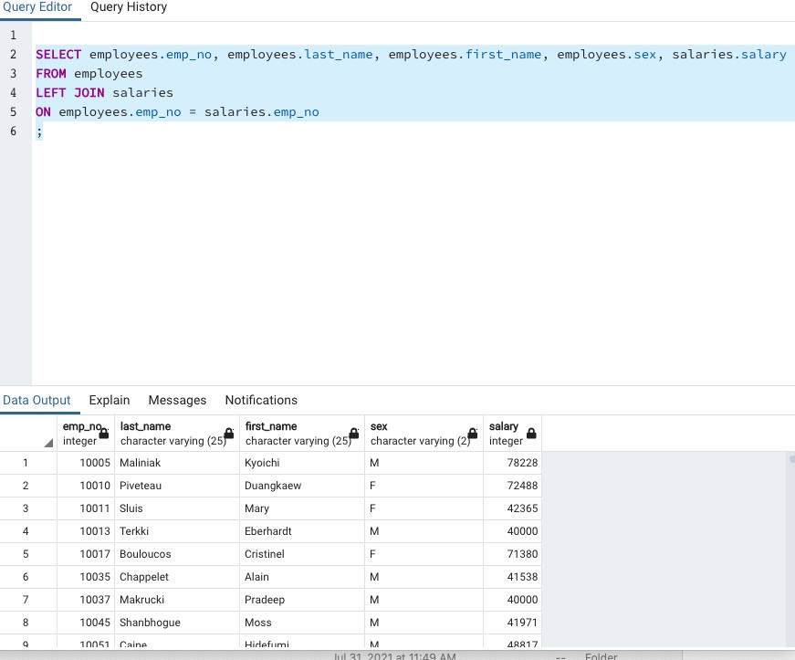

—2—

SELECT employees.first_name, employees.last_name, employees.hire_date

FROM employees

WHERE EXTRACT(year from hire_date) = 1986

;

*NOTE: add if you want to sort (not specified)*

*ORDER BY hire_date ASC;*

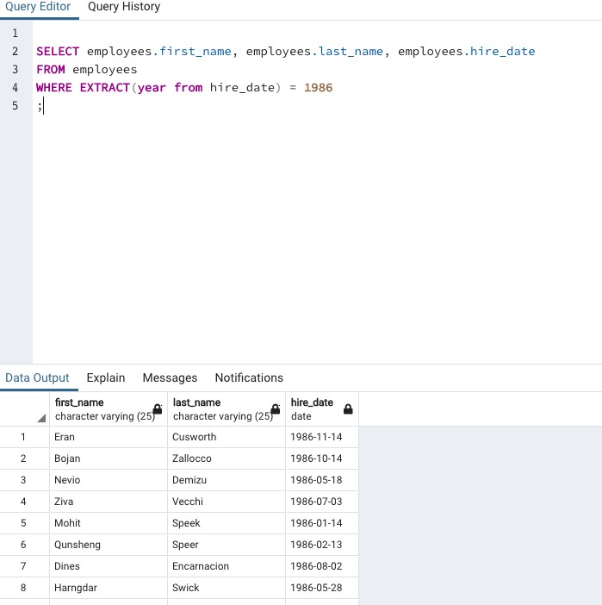

—3—

SELECT dept_manager.dept_no, departments.dept_name, employees.emp_no, employees.first_name, employees.last_name

FROM dept_manager

LEFT JOIN departments

ON dept_manager.dept_no = departments.dept_no

LEFT JOIN employees

ON dept_manager.emp_no = employees.emp_no

;

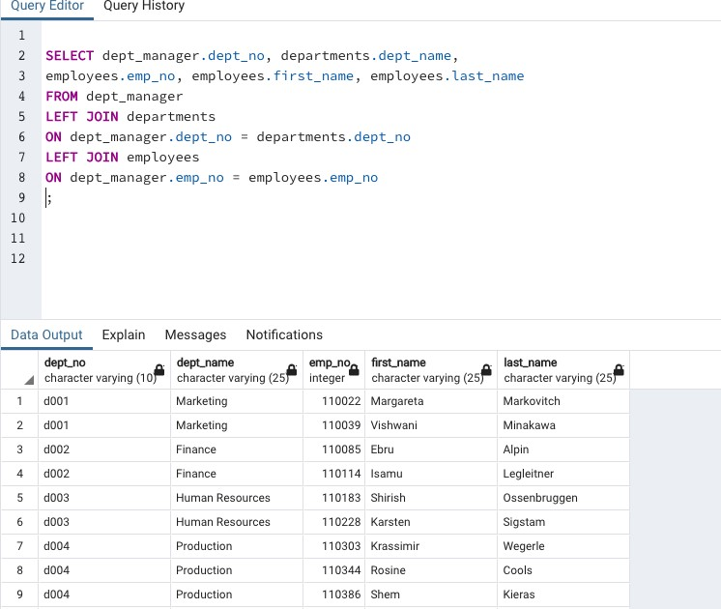

—4—

SELECT

employees.emp_no, employees.last_name, employees.first_name,

departments.dept_name FROM employees

LEFT JOIN dept_emp

ON dept_emp.emp_no = employees.emp_no

LEFT JOIN departments

ON dept_emp.dept_no = departments.dept_no

;

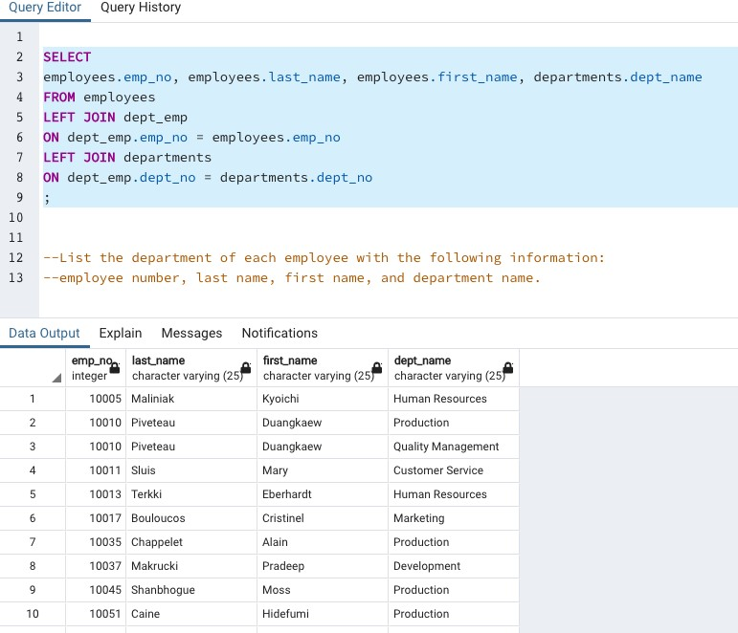

—5—

SELECT employees.first_name, employees.last_name, employees.sex

FROM employees

WHERE first_name = 'Hercules' AND last_name like 'B%';

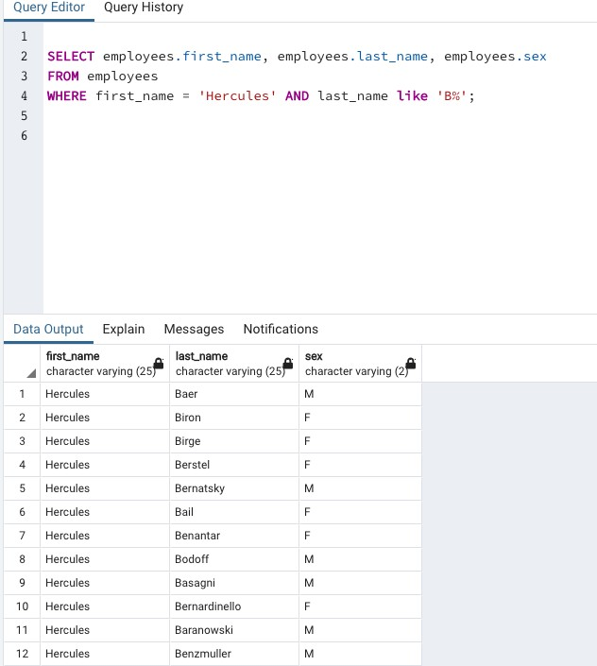

—6—

SELECT employees.emp_no, employees.last_name, employees.first_name, departments.dept_name

FROM employees

JOIN dept_emp

ON employees.emp_no = dept_emp.emp_no

JOIN departments

ON dept_emp.dept_no = departments.dept_no WHERE dept_name = 'Sales';

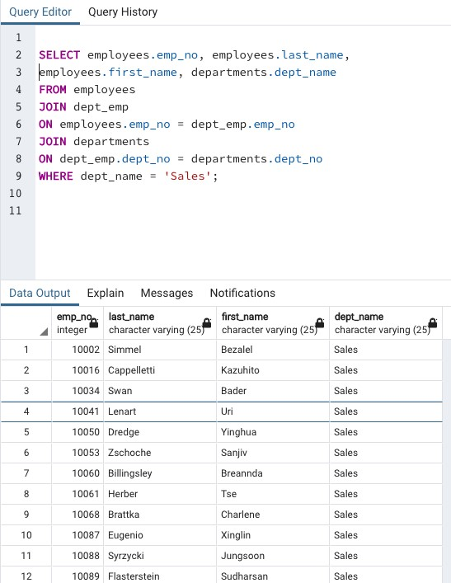

—7—

SELECT employees.emp_no, employees.last_name, employees.first_name, departments.dept_name

FROM employees

JOIN dept_emp

ON employees.emp_no = dept_emp.emp_no

JOIN departments

ON dept_emp.dept_no = departments.dept_no

WHERE departments.dept_name = 'Sales' OR departments.dept_name = 'Development';

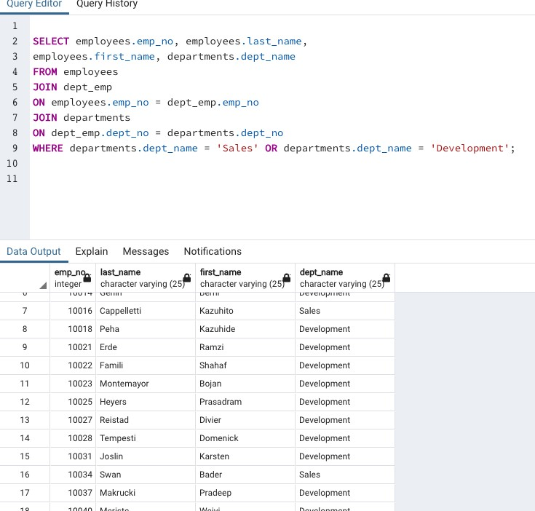

—8—

SELECT count(last_name) as "no_count", last_name

FROM employees

GROUP BY last_name

ORDER BY no_count desc

;

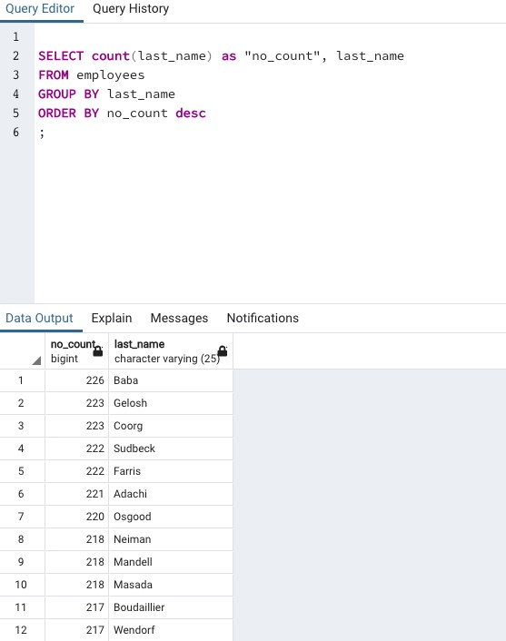

—EPILOGUE—

